**TITLE: PRODUCT AND SPECIFICATION MANUAL**

**1. Introduction**

This is a meter with RS232 and wireless GSM communication using Cicada GSM module. It has various event alerting functions including kWh remote reading and logging, using remote management and tampering provides customers a convenient remote reading method, on the air top-up. This meter is favored by customers and manufacturers with the features of high accuracy, wide measuring range and competitive cost performance.

**2. Tariff**

Tariff is software adjustable by energy provider as desired for meter.

**3. Communication**

Meter support RS232/2G/3G GSM, baud-rate: 115000.

**4. Measurement**

Meter measures voltage, current, active power and voltage is displayed on the 16x2 LCD, accumulative power and top-up history is logged every 24 hours on the web-based software.

**5. Mode**

Meter has 2 operation modes:

1. On the air top-up.

2. STS token mode using keypad.

**Over the air top-up**

Over the air top-up is done via the web-based software available, with meter to be topped up pre-registered with a unique meter-id, the rest is handled between the software and firmware to top-up the corresponding meter whose meter-id is entered automatically.

**STS operation**

Enter 20-digit token via keypad available on meter, the token is generated from the website in event of network failure or malfunction.

**6. Technical Parameter**

|  |  |
| --- | --- |
| **DESCRIPTION** | **SINGLE PHASE VALUE** |
| Accuracy | **CLASS 1** |
| **Voltage**  Reference voltage  Operating voltage range | 240 V  70% - 120% Reference voltage |
| Current | 5 (80A) |
| Frequency | 50Hz |
| **Temperature**  Operating range  Limit range for storage and transport | - 250C to 700 C  -400C to 1000C |
| **Power consumption**  Power consumption in voltage circuit(active)  Power consumption in voltage circuit(apparent)  Power consumption in current circuit | 2W  10VA  1VA |
| Communication Interface | DLMS / COSEM Compliance  (GPRS)First Electric web API |
| Dimension | 18cm x 15cm |
| Display: | LCD 16x2 |

**Indicator**

|  |  |  |
| --- | --- | --- |
| 1 | Credit Indicator | Bi-color LED (red)  Green LED light on when credit is in high level  Red LED light on when credit is low  Red LED blinks when credit has finished |
| 2 | Alarm indicator | The indicator blinks when event occur, event such as overload, low voltage, low credit or credit exhausted. |

**7. communication:**

1. RS232 communication, used for local reading/monitoring.

2. GPRS communication, used for on the air top-up, remote monitoring and controlling.

**8. Display of details on LCD**

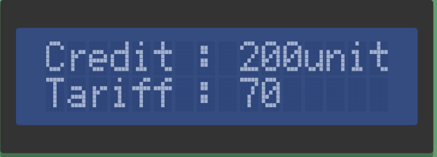



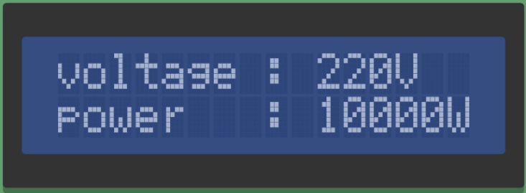

**9. Safety Instructions**

**Information for Your Own Safety**

This manual does not contain all the safety measures for operation of this equipment (module, device) because special operating conditions, local code requirements or local regulations may necessitate further measures.

**10. Qualified personnel**

Installation and operation, assembling of this equipment described in this manual may only be performed by qualified personnel. Only people who have good knowledge on power/embedded system should assemble this equipment.